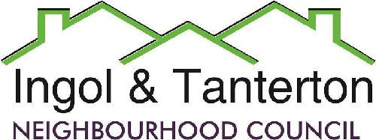
Gill Flynn - Clerk and RFO
Email: clerk@ingoltantertonnc.org.uk

Agenda

All Neighbourhood Councillors are hereby summoned to the meeting of
Ingol and Tanterton Neighbourhood Council on Wednesday 20th May 2026 at 7.15pm
at Tanterton Village Centre.

1.Election of Chair.

2.Election of Vice - Chair

3.To receive apologies.

4.To receive declarations of interest.

5.To approve the minutes of the meeting held on Tuesday 28th April 2026.

6.Public participation.

7.To consider planning applications, reports and matters.

8.Finance.
Expenditure
DD | EasyWebsites | Domain, hosting and emails | £56.76
BACS | HMRC | PAYE / NI/ Employment contributions | £276.03
BACS | Nurture | Monthly grass cutting schedule | £509.20
BACS | A Barnes | Internal auditor | £175.00

9.To consider the lengthsman’s update and schedule of works.
- To consider the costs for the relaying of the flagstones at TVC at a cost of £75.00.

10.To consider the update from the Area Enhancement Committee.
- Tanterton Village Shops
- New noticeboard for Ingol West Ward.

11.Reports and correspondence (information only).

12.Date and time of next meetings.

Press and public are welcome to attend.

